Configuring the receipt printer:
Scenario: The FC needs help configuring the receipt printer.

- Log into the AX5 point-of-sale system with your PIN.
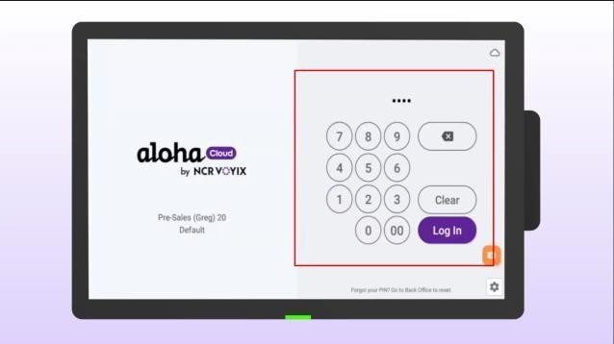
- Click the menu in the top left corner of the screen.
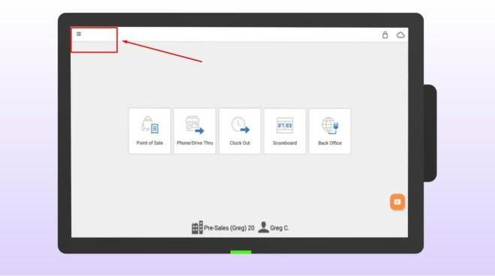
- Select SETTINGS.
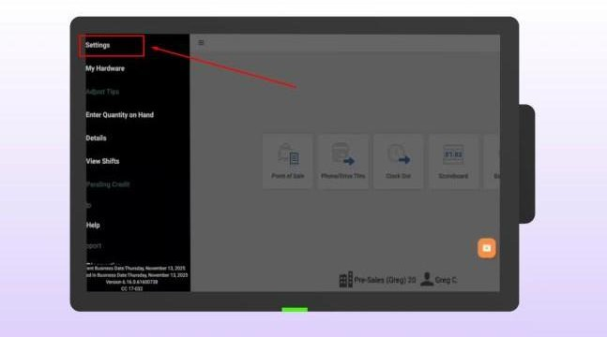

- Choose RECEIPT PRINTERS.
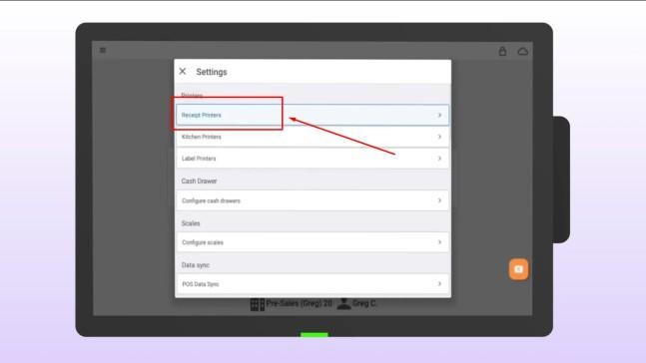

Tap ADD RECEIPT PRINTERS.
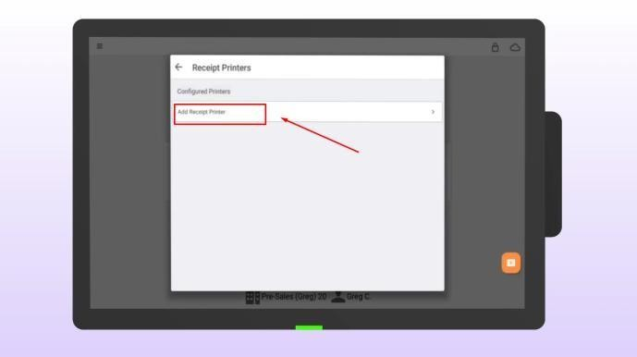
- Tap the printer's name to edit.
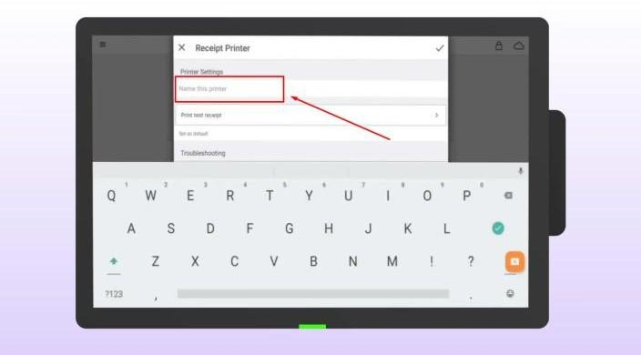

- Type a new, recognizable name.
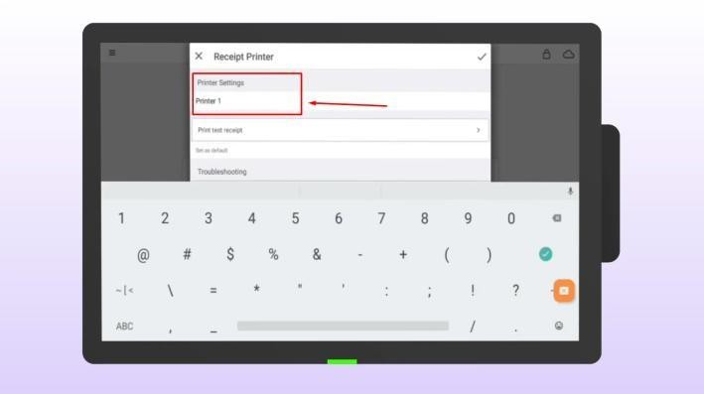
- Tap the check mark in the upper right corner.
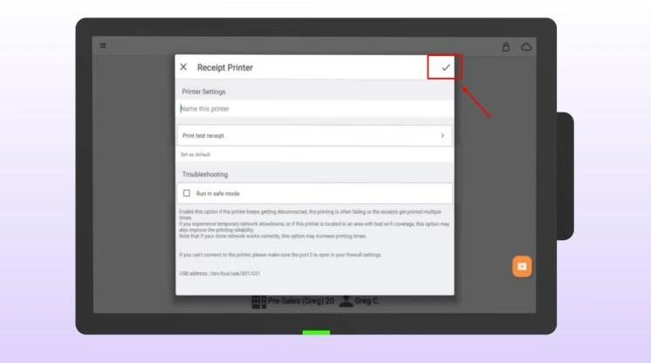

- Your printer setup is complete.

